Proceedings of the 2014 10th International Pipeline Conference
IPC 2014
September 29 - October 3, 2014, Calgary, Alberta, Canada
IPC 2014-33696

GEOMETRIC ANALYSIS OF PIPELINE ELBOWS THROUGH REVERSE ENGINEERING AND THEIR ASSOCIATED IMPERFECTIONS

Muntaseer Kainat  Graduate Student, Department of Civil and Environmental Engineering, University of Alberta  Edmonton, Alberta, Canada | Celal Cakiroglu  Graduate Student, Department of Civil and Environmental Engineering, University of Alberta  Edmonton, Alberta, Canada

Samer Adeeb  Associate Professor, Department of Civil and Environmental Engineering, University of Alberta  Edmonton, Alberta, Canada | J. J. Roger Cheng  Professor, Department of Civil and Environmental Engineering, University of Alberta  Edmonton, Alberta, Canada | Michael Martens  Sr. Mechanical/Pipe Stress Engineer, Design Engineering Support – Facilities Integrity, TransCanada Pipelines Limited  Calgary, Alberta, Canada

Abstract
Pipe elbow is a common feature in pipelines and piping systems as a means to changing directions of otherwise straight pipelines. Irrespective of the processes involved in manufacturing pipe elbows, it is of interest to investigate whether they have any geometric imperfections. Researchers at the University of Alberta have devised a technique to measure initial imperfection of straight pipes prior to testing, using high resolution 3D surface profiler in conjunction with 3D reverse engineering software. The objective of the current study is to extend the imperfections measurement technique from measuring straight pipe segments to pipe elbows. Six (6) ninety (90) degree elbows are measured in this research with outside diameters ranging from NPS 12 inch to NPS 42 inch. A 3D laser scanner is used to acquire surface data and create 3D models corresponding to each elbow. A method for the geometric analysis of the elbows is developed using 3D inspection and reverse engineering software Geomagic®. The geometric idealization of a pipe elbow is a torus, which can be defined by a circle revolving around an axis, coplanar with the circle. The idealized geometry for each elbow is obtained through the developed method of geometric analysis, which includes the diameter of the circle defining the torus, and its distance from the axis of revolution. The difference between the ideal torus and the scanned geometry is considered as imperfection of each pipe elbow. The wall thickness values at the ends or edges of select pipe elbows are also measured from the scanned data and are reported as percentage deviation from the specified wall thickness around the perimeter at different cross sections. The 3D reverse engineering of the elbows indicated that they resemble the ideal geometry very closely. The ovalization imperfections are seen to be well within the value specified by CSA Z662-11. The wall thickness deviations are seen to vary between -10% to +25% of the specified value, with increased thickness being more prominent in the elbows. Finite element analysis of an elbow with thickness imperfection shows that higher hoop stress appears on the intrados than initially intended.

INTRODUCTION
Steel elbows are used to change the direction of, otherwise straight, steel pipelines. The most common elbow angles are 45 and 90 degrees. Elbows are subjected to stresses due to the internal pressure that are higher than those in the straight portion of the pipelines. The additional stresses are caused by what is often referred to as “The Bourdon Effect” – which is the tendency of elbows to straighten when subjected to an internal pressure. Currently, there is no clear understanding of the extent of the “Bourdon Effect” on large diameter pipeline elbows. The additional stresses caused by the “Bourdon effect” can be exacerbated due to the existence of any manufacturing imperfections.
Previously, a method for creating the 3D surface profile of straight pipe segments with a 3D laser scanner has been developed [1]. A procedure to identify the geometric imperfections through reverse engineering of the scanned pipe segments and by comparing them with idealized geometry has also been performed [2]. This research focuses on extending the previously developed method for geometric analysis of straight pipe segments to the analysis of pipe elbows.
The ideal geometric representation of a pipe elbow is a torus. A torus can be defined by a circle revolving around an axis, which is coplanar with the circle. The objective of this research is to introduce a method for the geometric analysis of pipe elbows using a reverse engineering and inspection software Geomagic®. The as-built elbows are scanned and the idealized radius of the circle and the axis of revolution are obtained from the scanned data. The difference between the idealized geometry and the scanned geometry are deemed as the geometric imperfections of the pipe elbows. The wall thickness values of select pipe elbows near the edge are also measured and reported as percentage deviation from the specified wall thickness around the perimeter. The 3D reverse engineering of the elbows indicated that they resemble the ideal geometry very closely. The wall thickness deviations, however, are seen to vary between -10% to +25% of specified value. Increased wall thickness is found to be more prominent in the elbows. A finite element analysis of the elbow with wall thickness imperfections is performed to understand the effects of the thickness variation on the behaviour of the pipe elbow.
DATA ACQUISITION USING 3D LASER SCANNER
3D scanning technology is widely being used for reverse engineering and part inspection. A 3D scanner is able to reconstruct the shape of an object by creating point cloud on its surface and by extrapolating between these points. Different technologies are currently being used to acquire the shape of 3D objects. The 3D scanner used in this study is a non-contact scanner, which employs reflective positioning targets, laser cross, and the technique of triangulation for acquiring surface data. The reflective targets need to be applied at random on the surface to be scanned. Stereo vision enables the scanner to see and recognize the patterns of positioning targets. The position of the scanner relative to the surface is determined by triangulation as the laser light probes the surface to be scanned.
Prior to scanning the surface, the scanner creates a map of the positioning targets based on a minimum of four targets that initially appear in its field of view. Every new target in the field of view of the scanner is positioned relative to the ones visible in the previous fields of view. Thus, the error in detecting each target stacks and affects the coordinates of the position of the additional targets. A regular photogrammetric system, having a wider field of view, is able to conserve the accuracy of the scanner [3, 4]. Therefore, it is necessary to create a photogrammetry model of the targets by taking pictures. The scanner uses a reference cross and reference bars to label the coordinate origin and to maintain appropriate unit of measurement. Upon development of the photogrammetry model, the acquisition software has an accurate 3D map of all the targets placed on the surface. During scanning, the laser-cross sweeps over the surface and the data is recorded by the scanner. The output of scanning is an optimized surface rather than a point cloud. The acquisition software converts the raw data into unstructured triangulated surface with unit normal and vertices. This file format is known as Stereo Lithography or STL and can be used in a reverse engineering and inspection software for analysis. Before the scanning procedure is started, depending on the elbow size, they are either placed on the ground or lifted above ground using a fork lift (NPS 36 inch and bigger). Magnetic reflective targets are installed on the elbow surface. Reference cross and bars are attached to the elbow for creating the photogrammetry model.
In the first step, to create the photogrammetry model, pictures are taken from all sides and at different angles to capture all the reflective targets, the reference cross and the bars. Data acquisition software is used to ensure that the number of pictures taken is adequate to generate the photogrammetry model. After taking sufficient pictures, the photogrammetry model is created. The second step involves capturing the surface details of the elbow. The scanner is swept over the elbow surface at a desired speed and from a specific distance. Surface digitization is monitored real-time to detect discrepancies. In addition to the outside surface, the inside surface near the ends are also scanned for wall thickness measurements. Upon completion of the scanning procedure, the acquired surfaces are inspected in the data acquisition software to identify holes. The missing patches are scanned again until the surfaces are continuous, and the acquired data is deemed satisfactory for geometric analysis.
IDEALIZED GEOMETRY
As mentioned previously, the ideal representation of a pipe elbow is a torus, which is defined by revolving a circle about an axis which is coplanar with the circle (Figure 1 a). A plane that goes through the axis and bisects the torus is a plane of symmetry of the torus. This plane will be referred to as the vertical plane of symmetry in this research. Again, a plane that is perpendicular to the axis of revolution, and bisects the torus is another plane of symmetry and will be referred to as the horizontal plane of symmetry (Figure 1b). The point of intersection of the axis of revolution and the horizontal plane of symmetry is considered to be the centre of the torus.

Figure 1: a) The axis of revolution, circle, centre, and b) Vertical and horizontal planes of symmetry of an ideal torus

If an ideal torus is intersected using the horizontal plane of symmetry, the resulting curves will be two perfect arcs. The difference between the two radii of these arcs will be equal to the diameter of the circle, initially used to define the torus. If cross sections of the torus are taken using planes that go through the axis of revolution of the torus and are rotated about the same axis, the result will be perfect circles having diameters equal to the circle initially used to define the torus.
To represent a pipe elbow with an ideal torus, the diameter of the circle that defines the torus needs to be acquired, in addition to the distance from the centre of the circle to the axis of revolution. It is obvious that for an actual pipe elbow, the diameter of the circle and the distance will not be constant. If a cross section of an actual pipe elbow is taken using the horizontal plane of symmetry, the resulting curves will not be perfect arcs with constant radii. Also, if cross sections are taken using planes rotated about the axis of revolution, the resulting circular cross sections will have varying diameters.
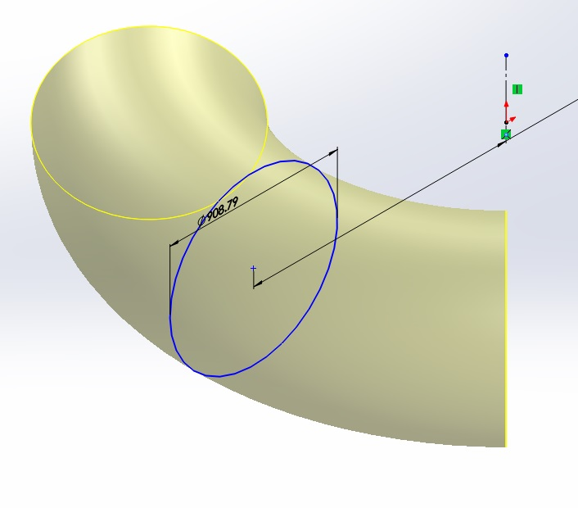
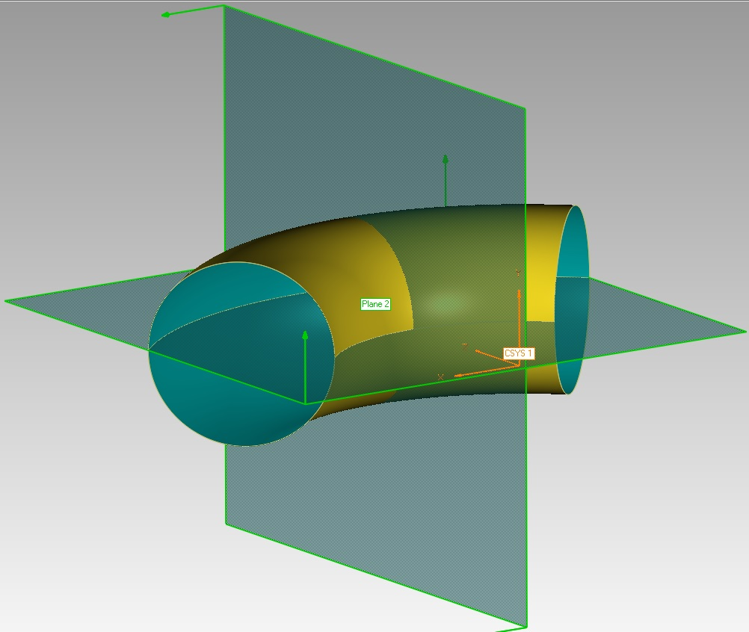
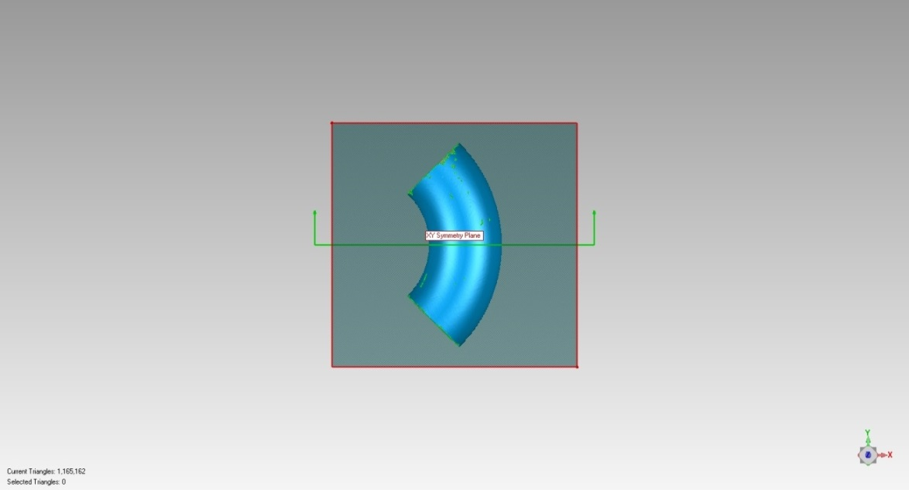
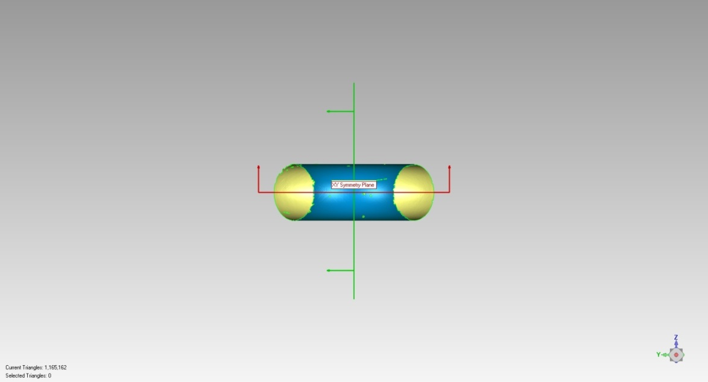
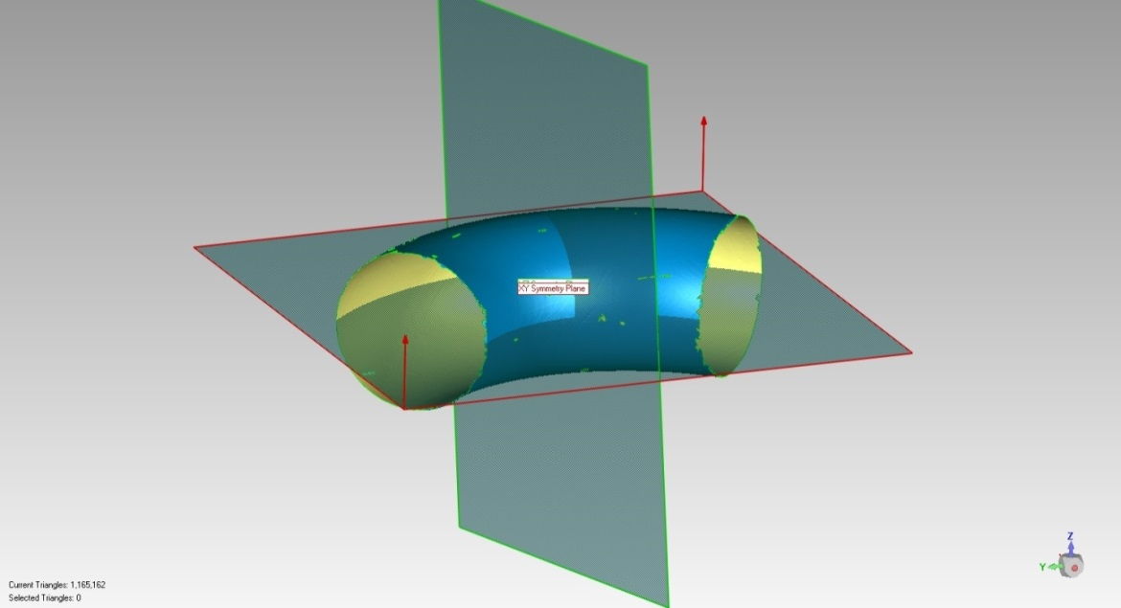
To represent an actual pipe elbow with an idealized geometry, the following tasks are performed using Geomagic®: First, the vertical and the horizontal planes of symmetry are obtained. A plane of symmetry can be described as an imaginary mirror in which an object can be reflected while appearing unchanged. Based on an initially specified plane where it roughly bisects the objects, Geomagic® fine-tunes the position such that the plane bisects the object more precisely. Using this tool, the two planes of symmetry for each scanned elbow data are obtained (Figure 2). The centre of the ideal torus will be on the intersecting line of these two planes.
Circle
Axis
Centre
a)
Horizontal Plane of Symmetry
Vertical Plane of Symmetry
b)

Figure 2: Planes of symmetry of a scanned elbow surface

Next, a cross section of the elbow is taken using the horizontal plane of symmetry. This gives two parallel curves. The outer curve, corresponding to the extrados of the elbow, is selected for curvature measurement. Using Geomagic®, an arc is fitted to the points on the outer curve with 1.0 mm tolerance. This ensures that the fitted arc never diverges from the actual cross section by more than 1.0 mm. The radius of curvature of the fitted arc is measured and recorded (Figure 3).
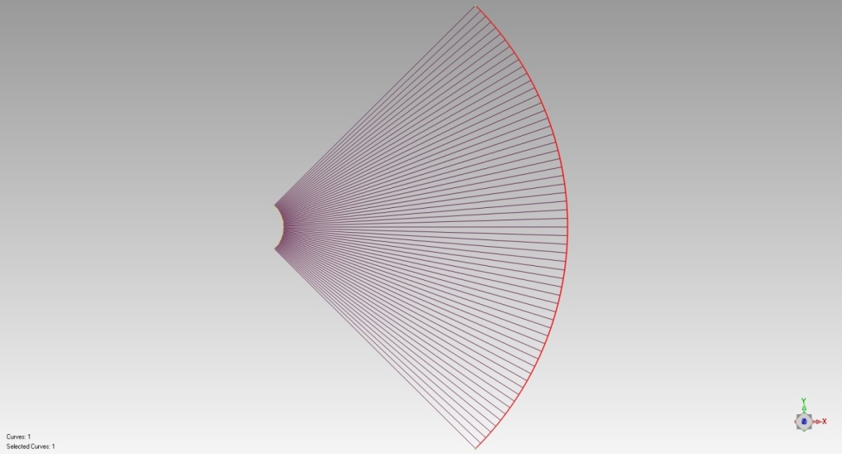
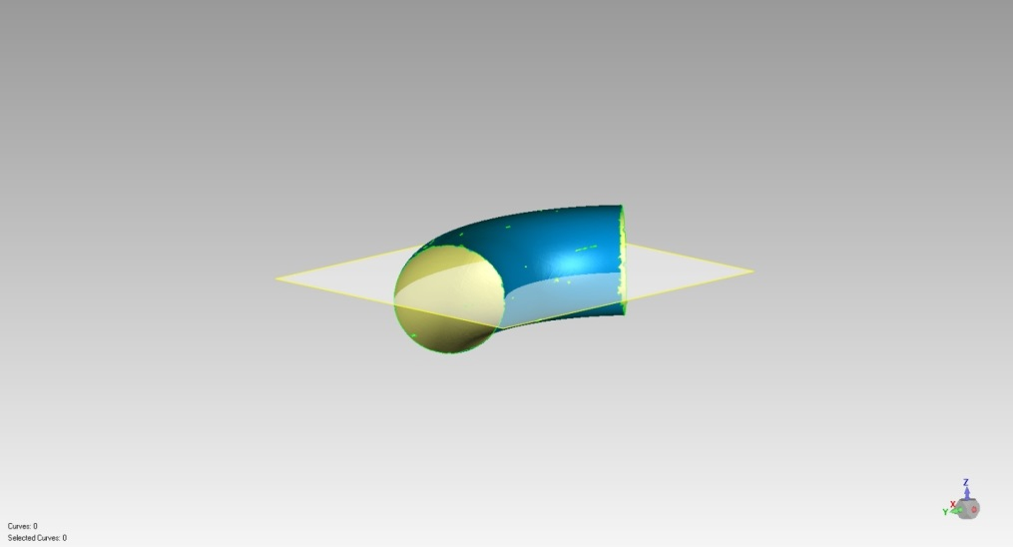
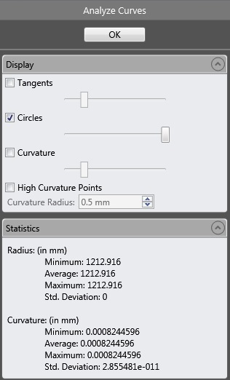
Figure 3: Radius of curvature of the outer curve of the elbow

To locate the axis of revolution, a slice of the elbow is extracted using planes offset from the horizontal plane of symmetry. Appropriate offset distance for each elbow is selected so that the surface along the height of the slice can be assumed planar. For example, in case of the 12 inch elbow, the trimming planes are taken at 2.5 mm offset on either side of the horizontal plane of symmetry. For the 36 inch elbow, the planes are taken at 10 mm offset. As a result, the sliced surface is almost planar across its height, and can be approximated as the curved surface of a cylinder. A cylinder is then created with the radius equal to the measured radius of curvature of the outer curve of the elbow, and the height is set equal to the height of the extracted slice of the elbow. The elbow slice and the cylinder are then aligned using a best fit alignment. During this procedure, the elbow slice remains fixed and the cylinder repositions itself until the average deviation between the elbow slice and the cylinder converges to a minimum. After alignment, the axis of rotation of the cylinder is obtained. This axis, therefore, is the axis of revolution of the torus that represents the elbow (Figure 4). The intersecting point of this axis and the horizontal symmetry plane is defined as the centre of the pipe elbow in this research.
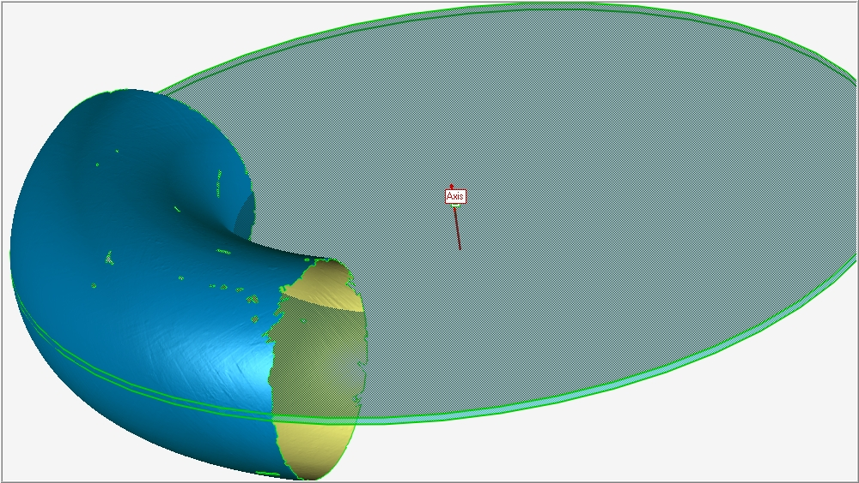
Cylinder
Elbow slice
Axis of revolution

Figure 4: Cylinder fitted to the selected slice of the elbow and its axis of rotation

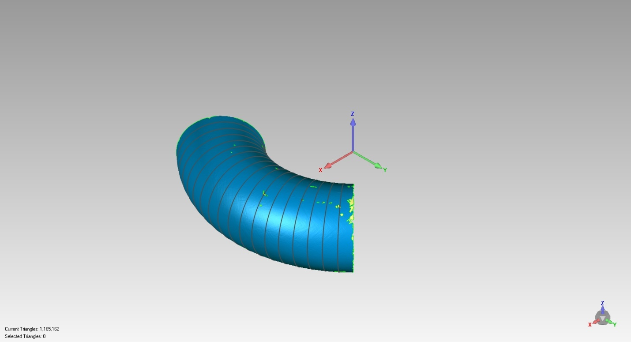
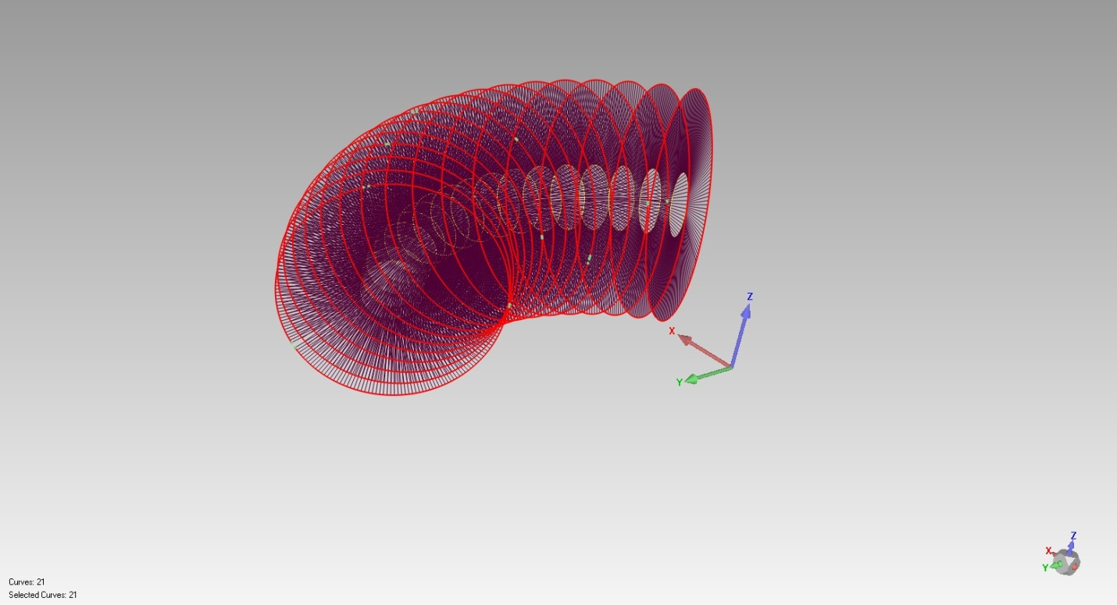
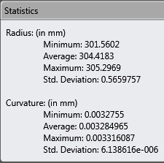
Figure 5: Average radius of elbow to be used to define the ideal torus

The elbow is aligned to the coordinate system so that the planes of symmetry and the centre coincide with two of the coordinate planes and the coordinate origin. Cross sections of the pipe elbow are taken on planes rotated about the axis of revolution of the elbow at 15 degrees angular interval. The diameters of each circular cross section are measured. The average diameter is taken as the diameter of the circle that defines the ideal torus (Figure 5).
The centroid of each cross section is obtained, and the distance of each centroid from the centre of the elbow is measured. The average distance is taken as the distance of the centre of the circle from the axis of revolution of the torus. Thus, the two geometric attributes necessary to represent a pipe elbow with an ideal torus are obtained.
imperfection measurement
The diameter of the circle and the distance from the centre of the circle to the axis of revolution corresponding to each scanned elbow are measured using the above mentioned method. Using these geometric attributes, ideal tori are created using the software Solid Works, and are exported to Geomagic®. The ideal tori are superposed on corresponding elbows. These are then compared to identify radii variation and ovalization patterns of the elbows.
The maximum and minimum values of the Outside Diameter (OD) are measured at cross sections taken at 5 degrees angular intervals around the axis of revolution. The ovalization value for each cross section is calculated according to the equation:

Ovalization Deformation = 2[(Dmax – Dmin) / (Dmax + Dmin)],

where, Dmax= maximum pipe OD, and Dmin = minimum pipe OD. The average ovalization value is calculated over multiple cross sections for each elbow.
Wall thickness values are measured at cross sections taken on planes through the axis of revolution. The thickness values are presented with respect to angles about a reference line that connects the centre of the cross section and the centre of the elbow. Angles are measured counter clockwise about the reference line.
Figure 6(a) shows a plane through the axis of revolution of an elbow, which is used to take cross sections for ovalization and wall thickness measurements. Figure 6(b) illustrates the schematics of the representation of the thickness measurement results. 0˚ and 360˚ angles correspond to the inside of the elbow cross section. 90˚ and 270˚ correspond to the top and bottom of the elbow cross section respectively. 180˚ angle corresponds to the outside of the elbow cross section.

Figure 6: a) Plane through the axis of revolution for taking cross section, b) Schematics of wall thickness measurement
RESULTS OF MEASUREMENT
The pipe elbows measured in this study comprise of two NPS 12 inch, two NPS 24 inch, one NPS 36 inch, and one NPS 42 inch elbow, which have been manufactured by Tectubi Raccordi. The specified wall thickness for the NPS 12 and 24 inch elbows is 9.525 mm, and for the NPS 36 and 42 inch is 12.7 mm. The specified and idealized outside diameter (OD), the distance of the circle from the centre (R), and the standard deviation between the ideal torus and the elbow surface (St. Dev) are listed in Table 1.

Table 1: Idealized geometry of elbows

Elbow | OD (mm) |  | R (mm) | St. Dev (mm)
 | Specified | Idealized
12inch_a | 323.85 | 322.63 | 457.37 | 0.4309
12inch_b | 323.85 | 323.34 | 456.78 | 0.3627
24inch_a | 609.60 | 608.84 | 908.14 | 0.6794
24inch_b | 609.60 | 609.67 | 909.18 | 1.1053
36inch | 914.40 | 908.79 | 1370.00 | 1.1535
42inch | 1066.80 | 1065.98 | 1615.58 | 2.6985

From the deviation analysis of each elbow surface and corresponding idealized torus surface, it is seen that 90% of the points on the torus surface lie within ±0.25% of OD of corresponding scanned elbow surface. To identify the ovalization patterns, a 3D deviation analysis of the actual and the idealized geometry were performed. Two distinct deviation patterns were observed as shown in Figure 7a, and 7b:

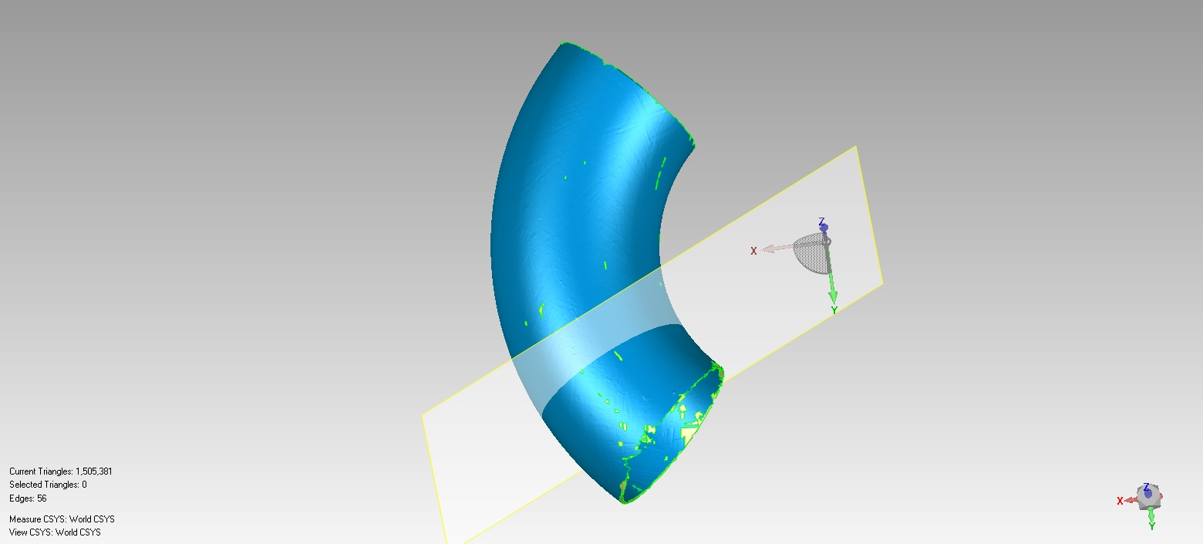
Figure 7: Ovalization patterns identified from the 3D deviation analysis of two elbows a) 12inch_b, and b) 24inch_b
Inside (0˚, 360˚)
X
θ
Reference Line
Top (90˚)
Outside (180˚)
Bottom (270˚)
Z
b)
a)

The colder colours indicate that the actual OD of the elbow is less than the ideal OD. The warmer colours indicate the opposite. In case of the elbow 12inch_b, the deviation pattern indicates that the elbow is ovalized in such a way that the minimum OD is oriented along the horizontal plane of symmetry. The elbow 24inch_b shows opposite ovalization pattern, with the maximum OD being oriented along the horizontal plane of symmetry.
The calculated ovalization values at different cross sections of each elbow (excluding 42inch) taken on planes rotated at 5 degrees angular intervals around the axis of revolution, along with the average and maximum values are listed in Table 2:

Table 2: Ovalization values of the scanned elbows

 | Ovalization Values
Angle | 12inch_a | 12inch_b | 24inch_a | 24inch_b | 36inch
-40 | - | 0.0101 | 0.0056 | 0.0051 | -
-35 | 0.0072 | 0.0075 | 0.0053 | 0.0049 | 0.0107
-30 | 0.0098 | 0.0069 | 0.0061 | 0.0066 | 0.0108
-25 | 0.0105 | 0.0078 | 0.0079 | 0.0072 | 0.0090
-20 | 0.0099 | 0.0074 | 0.0081 | 0.0074 | 0.0067
-15 | 0.0095 | 0.0081 | 0.0086 | 0.0084 | 0.0070
-10 | 0.0108 | 0.0082 | 0.0092 | 0.0080 | 0.0097
-5 | 0.0101 | 0.0079 | 0.0087 | 0.0093 | 0.0083
0 | 0.0093 | 0.0077 | 0.0084 | 0.0111 | 0.0094
5 | 0.0097 | 0.0082 | 0.0081 | 0.0115 | 0.0109
10 | 0.0092 | 0.0087 | 0.0067 | 0.0131 | 0.0116
15 | 0.0091 | 0.0075 | 0.0075 | 0.0140 | 0.0112
20 | 0.0084 | 0.0074 | 0.0084 | 0.0162 | 0.0075
25 | 0.0088 | 0.0077 | 0.0082 | 0.0165 | 0.0100
30 | 0.0081 | 0.0078 | 0.0093 | 0.0168 | 0.0146
35 | 0.0073 | 0.0056 | 0.0116 | 0.0156 | -
40 | - | 0.0048 | 0.0134 | 0.0132 | -
Average | 0.0092 | 0.0076 | 0.0083 | 0.0109 | 0.0098
Maximum | 0.0108 | 0.0101 | 0.0134 | 0.0168 | 0.0146

The wall thickness deviations are reported as percentages of the corresponding specified thickness of each elbow in Figures 8 through 10:

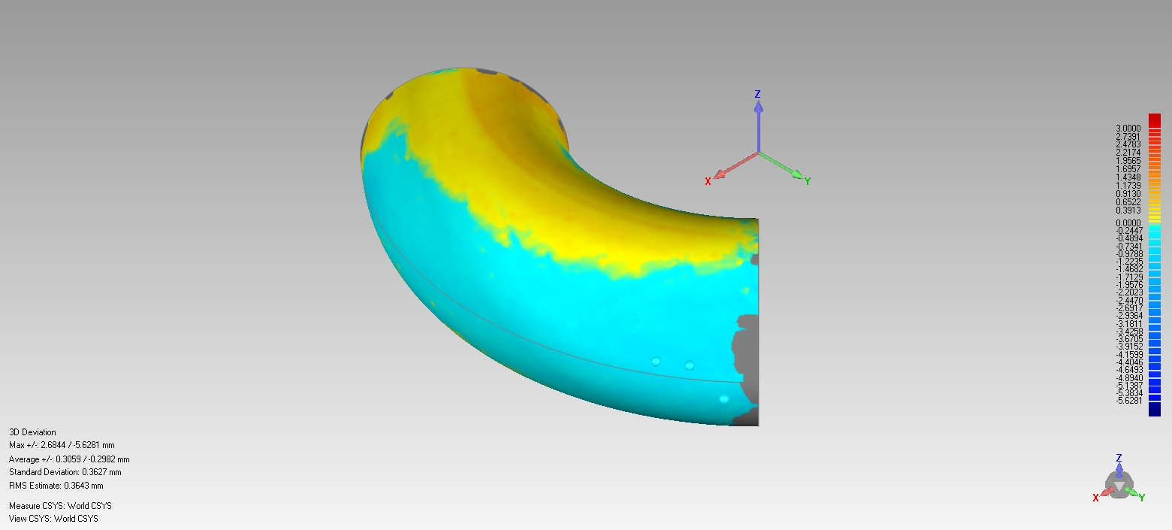
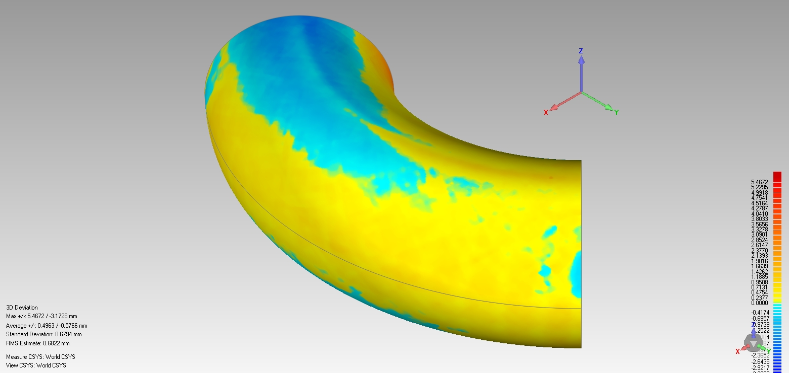
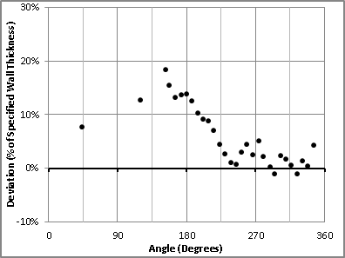
b)
a)

Figure 8: Wall thickness deviation of elbow 12inch_a

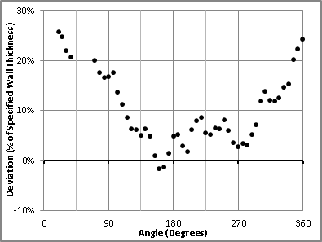

Figure 9: Wall thickness deviation of elbow 12inch_b

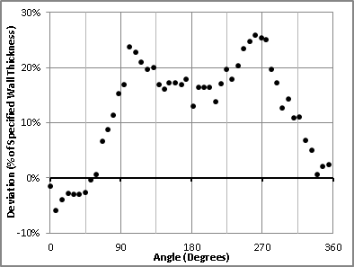

Figure 10: Wall thickness deviation of elbow 24inch_b
DISCUSSION ON MEASUREMENT RESULTS
From the comparison between the actual elbows and the idealized tori, it is seen that the idealized geometry is very close to the scanned elbow surfaces, with 90% of the points on the idealized tori within a deviation of ±0.25% OD of each elbow. For long radius elbows, a ratio of 3.0 between the bend radius and the mean cross sectional radius of an elbow is maintained by the manufacturers. From the geometric analysis of the scanned elbows, it is observed that the ratio of the idealized distance from the axis of revolution to the radius of the idealized circle is within a range of 2.83 to 3.03. Therefore, the idealization method developed in this study can be considered accurate.
The CSA Z662-11 (Oil and Gas Pipeline Systems) specifies a limit of 0.03 on ovalization in the absence of detailed information [5, C.6.3.3.4]. The average ovalization values of the elbows are in the range of 0.0076 to 0.0109, which are well below the CSA Z662-11 specification. The maximum ovalization values range from 0.0101 to 0.0168, which are also below the specified value of 0.03.
Two distinct patterns of ovalization were identified through the 3D deviation analysis. Intuitively, during manufacturing, an elbow should be ovalized in such a way that the minimum OD is oriented along the horizontal plane of symmetry and the maximum OD is along the vertical plane of symmetry. This pattern was observed in the two 12 inch elbows (Figure 7a). However, the pattern observed in the 24 inch elbow (Figure 7b) is opposite, with the maximum OD oriented along the horizontal plane of symmetry.
An elbow is manufactured by bending a straight pipe segment. The initially straight axis of the pipe is thus transformed to a curved axis during manufacturing the elbow. Theoretically, the axis of the straight pipe segment should be perfectly straight, and after manufacturing the elbow, its curved axis should be a perfect arc. In reality, the axis of a pipe segment is never perfectly straight, and the curved axis of an elbow manufactured from a pipe segment deviates from a perfect arc. Therefore, the deviation patterns observed from the 3D deviation analysis are in fact combinations of the ovalization of the elbow cross sections, and the deviation of the curved axis of the elbow from a perfect arc. As a result, a typical ovalization pattern, with the minimum OD oriented along the horizontal plane of symmetry, could not be identified.
Patterns of wall thickness deviation were observed for the three select elbows. 12inch_a had wall thickness deviation values close to 0% on the inside (0˚, 360˚), which increased uniformly to 20% of the specified thickness on the outside (180˚). 12inch_b had increased wall thickness (25% of specified thickness) on the inside and close to 0% deviation on the outside. 24inch_b had decreased wall thickness (7.5% of specified thickness) on the inside and increased thickness (25% of specified thickness) near the top (90˚) and bottom (270˚) of the elbow. The 42 inch elbow did not have negative wall thickness deviations. It showed increased thickness in the order of 10% to 25%. Thickness reduction is seen to be within 7.5% of the specified thickness of all three elbows. Increased thickness is seen to be more prominent in all the elbows (15% to 25% of specified thickness). Intuitively, decreased thickness was anticipated on the extrados (at 180˚) of all the elbows. The otherwise observed patters can be attributed to the initial thickness deviation of the steel plate used to manufacture the straight pipe segment.
eFFECTS OF THE GEOMETRIC IMPERFECTIONS
To investigate the effects of the geometric imperfections identified through the aforementioned geometric analysis, numerical modeling of an elbow was performed. Finite Element Analysis (FEA) software ABAQUS was used for the numerical analysis.
A Grade 359 steel 24 inch OD elbow with 9.525 mm specified wall thickness was selected for the analysis. The idealized geometry of the elbow 24inch_a was used to create the elbow model without any geometric imperfections. Among the imperfections identified previously, only the wall thickness variation was included in the geometry of the imperfect elbow. It has been seen previously that the ovalization imperfection within the CSA Z662-11 specified limit has no influence on the buckling response of straight pipes, while the deviation of wall thickness from the specified value reduces the load carrying capacity under pure bending [6]. The ovalization imperfections in the elbows were observed to be well within the CSA Z662-11 specifications, and were not included in the numerical analysis. The wall thickness deviation shown in Figure 10 was selected for the thickness imperfection. A thickness imperfection model had to be developed to be included in the analysis; therefore, the data points were fitted with a simple Sine curve as shown in Figure 11:

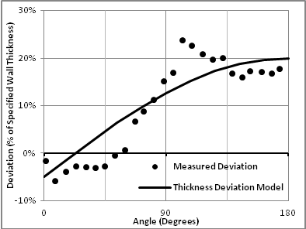

Figure 11: Measured thickness deviation and the thickness deviation model

The thickness deviation model was incorporated into the FEA model through the use of a spherical coordinate system, with its origin coinciding with the centre of the elbow. The thickness variation was input as a function of the radial distance of the elbow wall from the coordinate origin. The resulting wall thickness deviation spectrum is shown in Figure 12:

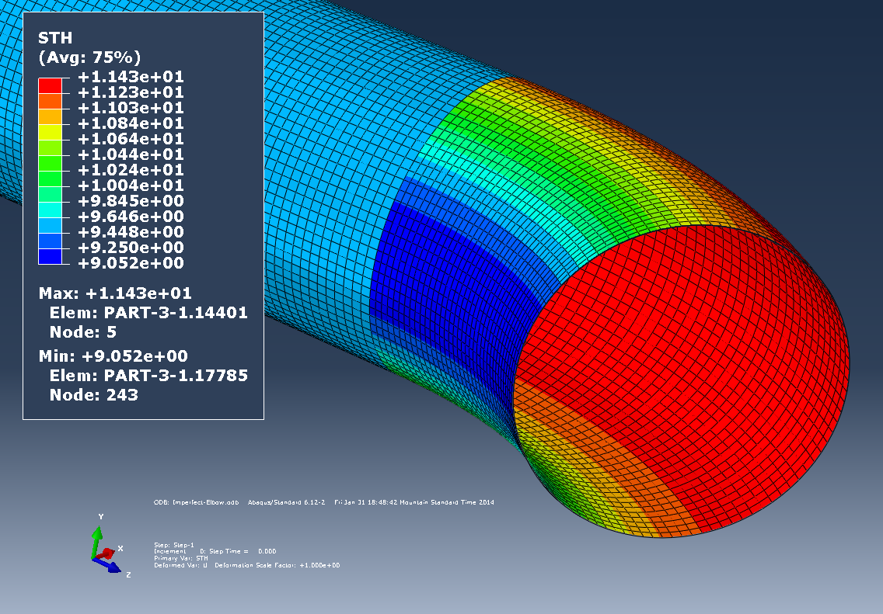
Figure 12: Shell thickness deviation spectrum corresponding to the wall thickness deviation model

The elbows were modeled with 1500 mm long straight pipes attached to their ends. The straight pipe ends were restrained from all rotation and translation except for translation in the radial direction. This ensured that no local bulging would form at the ends due to pressurization. Therefore, the unrestrained length of the elbow ends were 1500 mm on each side (Figure 13).
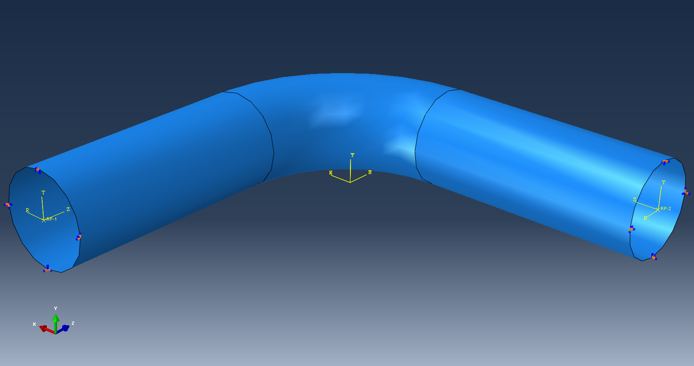
Figure 13: Unrestrained length of straight pipe attached to the elbow and the prescribed boundary conditions at the ends

Grade 359 steel was modeled as Isotropic Elastic Plastic material, with 207000 MPa Young's Modulus, and 0.3 Poisson's Ratio. The uniaxial stress-strain curve was modeled based on coupon test results and using the Ramberg-Osgood model. The equivalent plastic strains and corresponding yield stresses were calculated and input into the FEA model. The Ramberg-Osgood stress-strain curve along with the uniaxial stress-strain response obtained from the finite element analysis of a single plane stress element is shown in Figure 14.

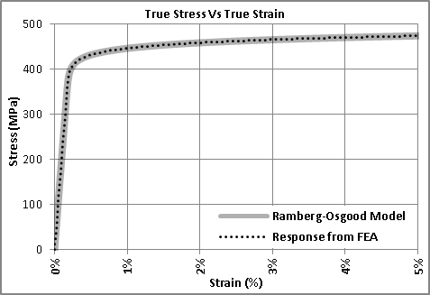

Figure 14: Ramberg-Osgood material model and material response obtained from FEA

An internal pressure that results in hoop stress equal to 80% of the Specified Minimum Yield Strength (SMYS) was calculated to be 9 MPa for a 24 inch OD straight pipe and 9.525 mm wall thickness. Accordingly, 9 MPa internal pressure was applied to the elbows and the straight pipe segments to see the differences in behaviour of the elbows with and without the wall thickness imperfections. It was seen that both elbows translated outwards from their initial position and were ovalized (Figure 15). This is due to the fact that the extrados have a larger surface area than the intrados of the elbow. Accordingly the resultant force due to internal pressure acts outwards and tends to translate the elbow in that direction. The ideal elbow translated 8 mm and its final ovalization was 0.0366. The elbow with the thickness imperfection translated 7.5 mm, and its final ovalization was 0.0373.

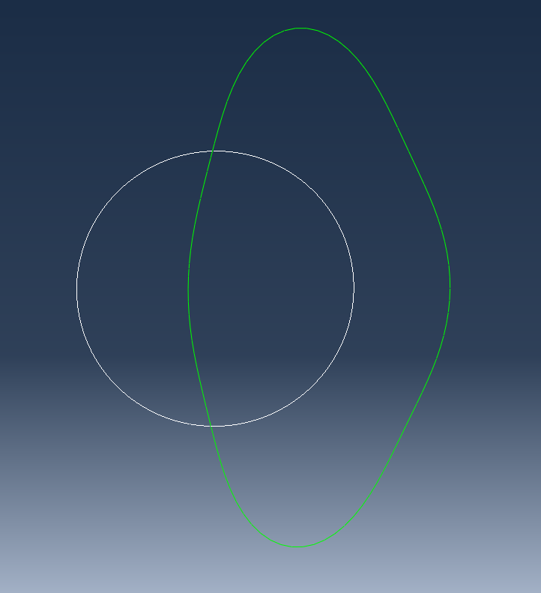
Figure 15: Cross section of elbow through the vertical plane of symmetry before and after pressurization (magnified 20 times)
The Von Mises stress distributions show that both elbows have higher stresses on the intrados compared to the extrados. The maximum Von Mises stresses on the ideal and imperfect elbows were seen to be 321 MPa and 336 MPa respectively (Figure 16)
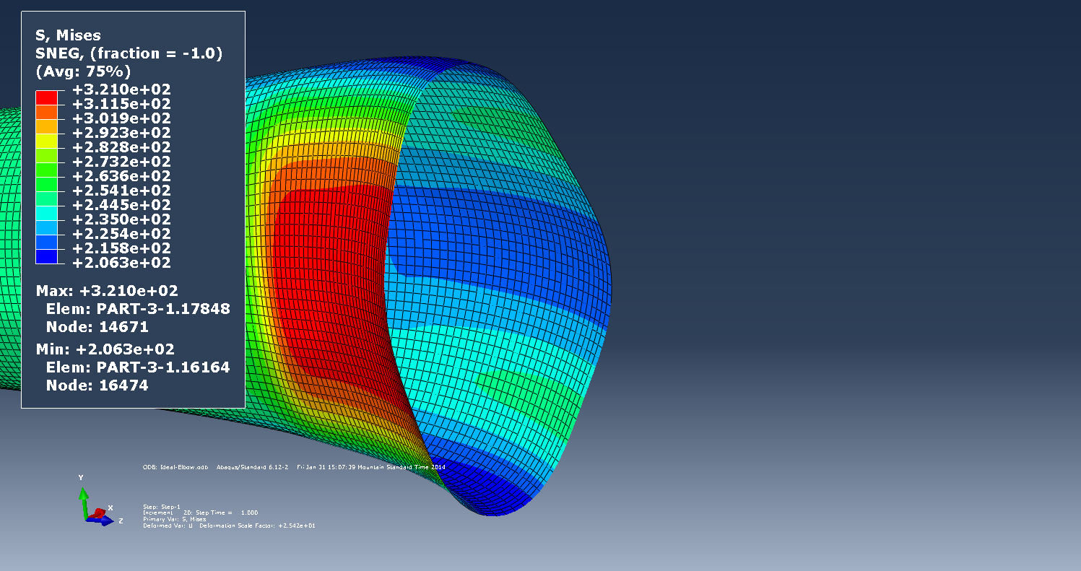
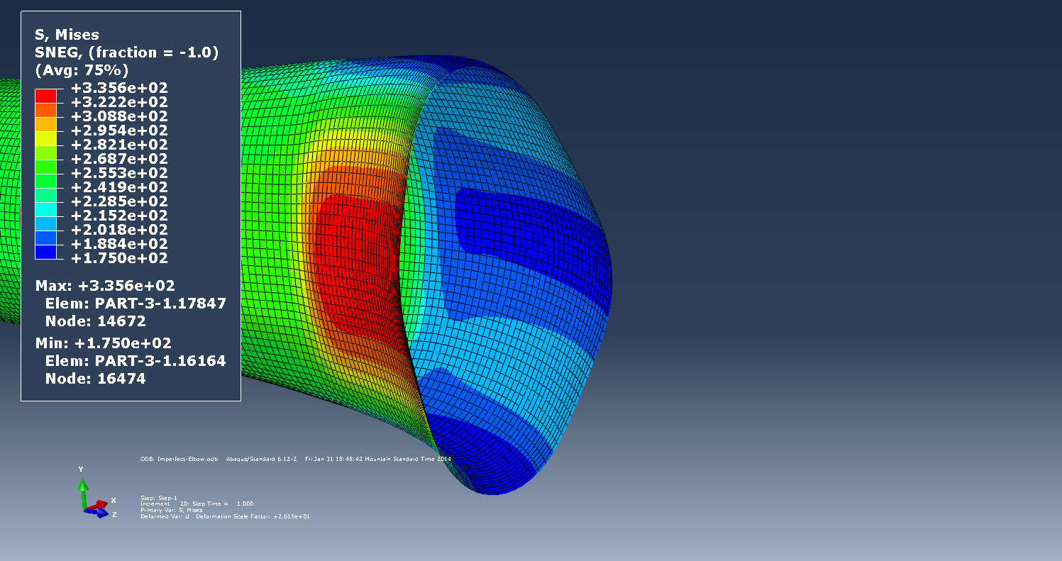
b)
a)

Figure 16: Von Mises stress distribution on the intrados of a) Ideal and b) Imperfect elbow after pressurization

The stresses in the hoop direction were seen to be higher than 80% of the SMYS on the intrados of both elbows. The ideal and the imperfect elbows showed 368 MPa and 385 MPa hoop stresses respectively.
To investigate the effect of using a thicker elbow than the straight pipe, another FEA was performed with a higher wall thickness of 12.7 mm, and with the thickness imperfection imposed on it. It was seen that the behavior of the elbow significantly improved due to increased thickness. The outwards translation was reduced to 6.8 mm. The final ovalization after the application of internal pressure was 0.0274, which is below the CSA Z662-11 specification. The maximum Von Mises and hoop stresses on the intrados were reduced to 254 MPa and 292 MPa respectively. The hoop stress is seen to be 81% of the SMYS, which is fairly close to the CSA Z662-11 specification of 80% of SMYS.
CONCLUSIONS
This research successfully devised a method for the geometric analysis of pipe elbows through 3D scanning and reverse engineering. The idealized geometry obtained from the developed method is very close to the actual geometry of the scanned elbows, with 90% of the points on the surface of the ideal elbows within a deviation of ±0.25% OD of each corresponding scanned elbow. The ratio of the idealized distance from the axis of revolution to the radius of the idealized circle is seen to be very close to 3.0 for all the scanned elbows.
The ovalization imperfections initially present in the elbows are well below the limit specified by CSA Z662-11. Two patterns of ovalization are identified. It is concluded that the out of straightness of the initial straight pipe axis as well as the deviation of the curved axis of the manufactured elbow from a perfect arc is responsible for the observed patters of ovalization.
Patterns of wall thickness deviation are also identified in this research. Increased thickness in the range of 15% to 25% of the specified wall thickness is observed. Thickness reduction is seen to be within 7.5% of the specified wall thickness. The counter intuitive patterns of thickness deviation observed from the geometric analysis are attributed to the pre-existing thickness deviation of the steel plates used for manufacturing the pipes.
The FEA of the ideal and imperfect elbows demonstrated that both elbows exhibit ovalization beyond the specified limit at the maximum applied pressure. The outwards translations of the elbows indicate that at the maximum pressure, the support system used to fix the elbow in position will be subjected to lateral forces. The maximum hoop stresses due to the applied internal pressure in both elbows are seen to be greater than that intended to be applied (80% SMYS). However, it is also seen that using the next higher wall thickness available for the elbow reduces the outward translation, the ovalization deformation, and the hoop stresses. The translation is reduced by 9%, the ovalization deformation is reduced by 26.5%, and the hoop stress is reduced by 24% compared to the imperfect elbow with wall thickness equal to the attached straight pipes.
Acknowledgments
The authors thank TransCanada PipeLines Ltd. for supplying the sample segments of the pipe elbows as well as for their financial support. The authors also acknowledge the cooperation of the employees of Allied Fittings in Sherwood Park during this research. The Natural Sciences and Engineering Research Council is gratefully acknowledged for their financial support.
References
[1] Kainat, M., Adeeb, S., Cheng, J.J.R., Ferguson, J. and Martens, M. 2012. Measurement of Initial Imperfection of Energy Pipelines Using 3D Laser Scanner. Proceedings of the 3rd International Structural Specialty Conference, CSCE, Edmonton, Alberta, Canada.
[2] Kainat, M., Adeeb, S., Cheng, J.J.R., Ferguson, J. and Martens, M. 2012. Identifying Initial Imperfection Patterns of Energy Pipes Using a 3D Laser Scanner. Proceedings of the 9th International Pipeline Conference, IPC, Calgary, Alberta, Canada.
[3] Money, C., Brown, D. and Herbert, P. 2011. Intelligent Measurement Processes in 3D Metrology: Producing More Accurate Point Clouds. Creaform
[4] Creaform Knowledge Base: Documentation Manual
[5] Canadian Standards Association, 2011. Z662-11 Oil and Gas Pipeline Systems. Canadian Standards Association, Etobicoke, Ontario, Canada.
[6] Kainat, M., Adeeb, S., Cheng, J.J.R., Ferguson, J. and Martens, M. 2013. Effects of Material Anisotropy and Geometric Imperfections on the Buckling Response of X100 UOE Pipes – A Finite Element Study. Proceedings of the 3rd Specialty Conference on Material Engineering and Applied Mechanics, CSCE, Montreal, Quebec, Canada.

